**PROJECT DESCRIPTION**

# **PROJECT INFORMATION**

* **Project Title**

| INFINITY CRM WEBSITE | | | |
| --- | --- | --- | --- |
| Submitted by | Submitted to | Date submitted | Project start date |
| ISD01_GR06 | Mrs. Dinh Thi Minh Nguyet | 13/03/2024 | 22/02/2024 |

* **Project Owner**

| Nguyen Bao Trung | CEO - Infinity Financial Solutions (Vietnam) Company Limited.  He has 7 years of experience in financial consulting, telesales and customer data management. |
| --- | --- |

* **Project Members**

| Full name | ID Student | Email |
| --- | --- | --- |
| Nguyen Thi Chuc | 2101040043 | chuc2003glhd@gmail.com |
| Vu Thi Thom | 2101040176 | vuthom1407@gmail.com |
| Nguyen Minh Quang | 2001040175 | minhquang19122002@gmail.com |
| Nguyen Duy Thang | 2001040185 | tn565791@gmail.com |
| Kieu Hoang Minh Hieu | 2101040087 | kieuphuonghoai@gmail.com |

* **Revision History**

| Date | Version | Description | Author |
| --- | --- | --- | --- |
| 11/03/2024 | 1.0 | Section 1 - 4 in project description | Vu Thi Thom |
| 12/03/2024 | 2.0 | Section 5 - 8 in project description | Nguyen Thi Chuc |

# **CUSTOMER DESCRIPTION**

Infinity Financial Solutions (Vietnam), which was founded in 2019, is a firm that offers financial solutions to private clients. Putting clients' financial objectives initially, through warm consulting calls, the company supports customers in creating accounts to participate in trading on the exchange. The consensus, enthusiasm, desire to contribute, and bravery of the company's officers, employees, and leaders are always a solid foundation to help Infinity quickly break through in the coming period.

# **BUSINESS PROCESS**

# **3.1. Functional Areas and Business Process**

* **Functional Areas**

*1/ Business Department:*

* Responsible for finding and developing new customers.
* Introducing the company's products and services.
* Negotiate and sign contracts.

*2/ Financial Consulting Department:*

* Analyze customers' financial situation.
* Monitor the market and advise customers to make appropriate investment decisions.
* Manage customer investment portfolios.

*3/ Legal Department:*

* Provide legal advice to the company.
* Drafting and evaluating contracts.
* Ensure the company complies with legal regulations.

*4/ Accounting department:*

* Financial management of the company.
* Monitor income and expenditure and prepare financial reports.
* Ensure the company complies with tax regulations.

*5/ Customer Care Department:*

* Answer questions and advise customers.
* Support customers in the process of using products and services.
* Maintain good relationships with customers.

*6/ Human resources department:*

* Recruitment and training of employees.
* Manage human resources-related issues such as salaries, bonuses, and insurance.
* Make sure the company has enough human resources to meet operational needs.

*7/ Marketing department:*

* Develop and implement marketing strategy.
* Promote the company's brand and products.
* Increase brand awareness and attract potential customers.
* **Business Process**

*1/ Contact and information collection:*

* Customers contact the company through channels such as the website, email, or hotline.
* The consultant will receive basic information about the customer, their needs, and financial goals.

*2/ Analyze the financial situation:*

* The consultant will collect detailed information about the customer's financial situation, including income, expenses, assets, and debts.
* Based on the information collected, the specialist will analyze and evaluate the customer's current financial situation.

*3/ Develop a financial plan:*

* Consultants will build personalized financial plans for customers based on their needs, goals, and financial capabilities.
* A financial plan can include goals such as savings, investing, debt management, and insurance.

*4/ Present and discuss the plan:*

* The consultant will present the financial plan to the client in detail and explain the proposals in the plan.
* Customers can ask questions, suggest modifications, and discuss to complete the plan that best suits their needs.

*5/ Signing the contract:*

* After agreeing on the financial plan, the two parties will sign a consulting service contract.
* The contract will clearly state the rights and obligations of both parties, including the scope of services, service fees, and implementation period.

*6/ Implement the plan:*

* Consultants will assist customers in implementing the agreed financial plan.
* Support may include providing information, documents, guidance, investment advice, and asset management.

*7/ Monitor and evaluate:*

* The consultant will monitor the progress of implementing the customer's financial plan and evaluate the effectiveness of the plan.
* Based on the assessment results, experts can propose adjusting the plan to suit the actual situation.
* Customers can contact the company for advice and support when necessary.

# **3.2. Business Process Diagram**

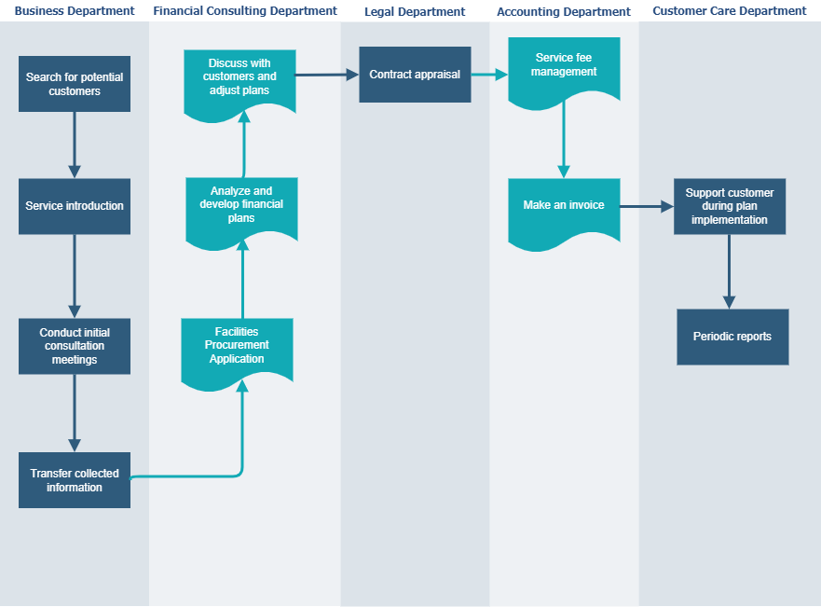

# **PROJECT SUMMARY**

# Objective: Build a professional and flexible working website to help improve the productivity of each employee and avoid communication breakdowns with customers.

# Result: Create a new and quality corporate working environment, enhance company value, and promote customer trust

# Importance: Ensuring the security of company and customer data.

# Economic benefits: Promote customers' desire to use services, thereby increasing revenue and creating value for businesses.

# **SIGNIFICANCE AND INNOVATION**

The necessity of utilizing technology in every business's customer and human resource management has increased due to the swift advancement of technology. Our customer no longer needs to keep as many documents as it did in the past because the traditional management approach takes too long and increases the risk of mistakes.

The most crucial aspect of financial telesales is customer data management. Infinity’s employees can readily access customers and ensure they don't miss any of their data segregated by the customer, and managers can quickly assess the overall status of each client.

As a result, this project will result in the development of a website that will help Infinity company manage their clients and staff in an effective and straightforward manner. Furthermore, despite its beautiful layout, the website nevertheless includes critical administration services such as customers and employees information, status, and add, edit, delete data function that is useful for our customer who is admin or manager.

# **APPROACH**

| METHODOLOGY | Agile |
| --- | --- |
| PROGRAMMING LANGUAGES | HTML, CSS, JavaScript, Java, MySQL |
| TECHNOLOGY | * Google Drive, Google Docs, Google Sheet: Used to store project’s documents and processes * Word, Excel, PowerPoint: Used to write documents, data * Visual Diagram: Used to design Use-Case diagrams * Figma: Use to create mock-up of website * Intellij IDEA, Visual Studio Code: Used to write code for the website * GitHub: Used to manage the website’s source code * Jirra: Manage and control project easily and customer can keep track the progress |
| TEAM COMMUNICATION | * Zalo * Google Meet |

# 

# **EXPECTED OUTCOMES**

Built a successful customer management website with two objects: employees and administrators (managers).

The interface of the website must match the GUI design and the style of the company.

The website should include all the functions the company needs and wants.

The website must have complete information about the company, including branches and how to contact the company.

Websites should have clear, eye-catching, easy-to-understand headlines, images, and text. Customer information is complete and clear.

The website must be simple to use, allow staff to access client data quickly and easily, and make the staff and manager experience quicker and more pleasurable.

The loading time and performance of the website should be optimized.

# **DESCRIPTION OF PERSONNEL**

| Member | Role |
| --- | --- |
| Nguyen Thi Chuc | PM, BA |
| Vu Thi Thom | BA |
| Nguyen Minh Quang | Coder |
| Nguyen Duy Thang | Tester |
| Kieu Hoang Minh Hieu | Coder |